Install the Visual Studio code on Windows 10

C# and version 10

Link: <https://code.visualstudio.com/>

Install Visual studio code IDE

Link: <https://dotnet.microsoft.com/en-us/download>

Install the .Net SDK on the windows 10.

After install .Net SDK ,Check the dotnet version

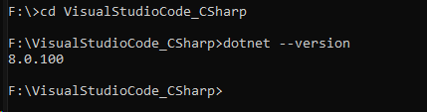

Go to the your created project directory folder and Type “dotnet new console”

This command will create the csharp project

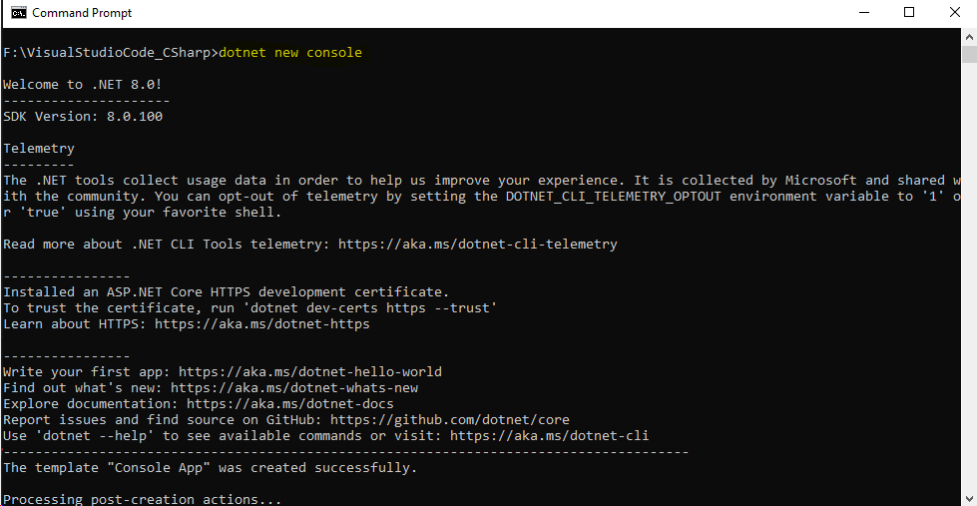

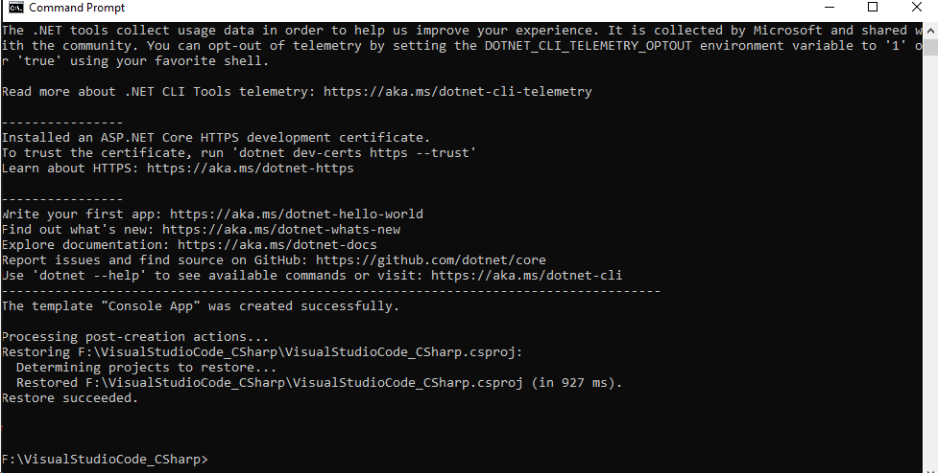

Type “code .” on cmd prompt

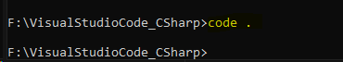

Here is the Example of project structure on visual Studio code IDE

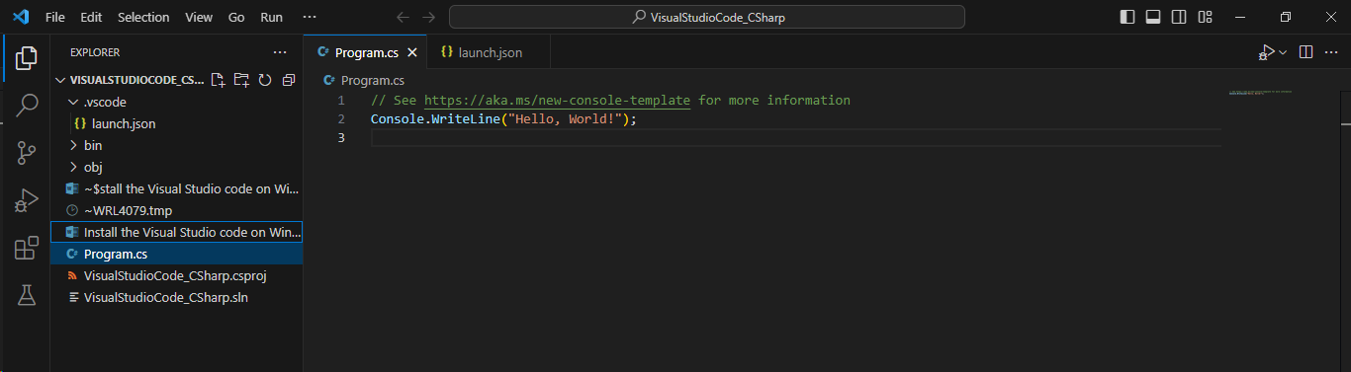

There are two ways to run the C# program in visual Studio

1. Terminal method

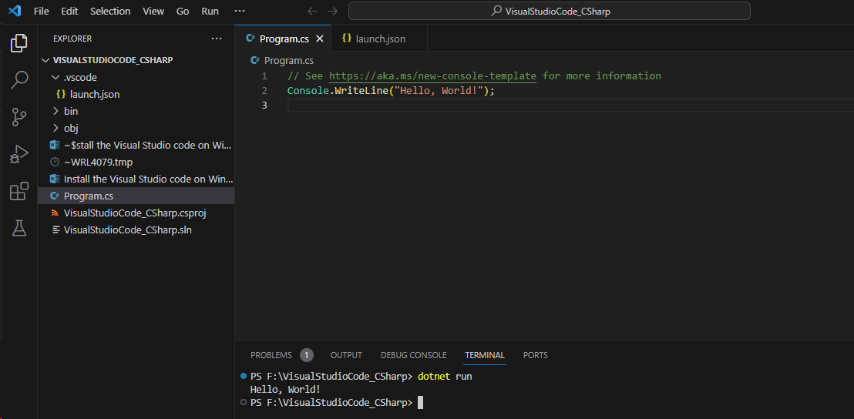

2. code run method

Install the Code Runner

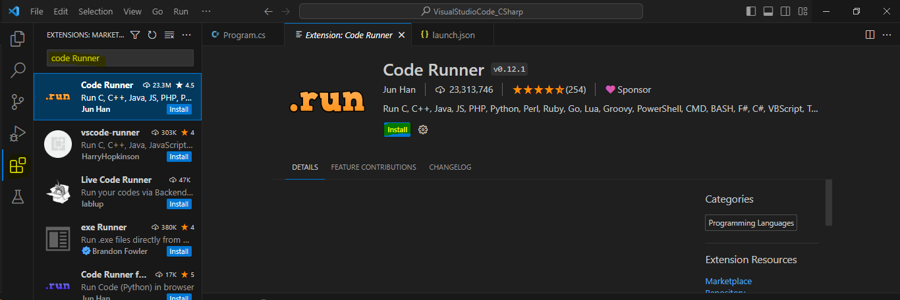

File ->Preference->Settings

Type “run in terminal”

Below enable the “code-runner:Run in Terminal”

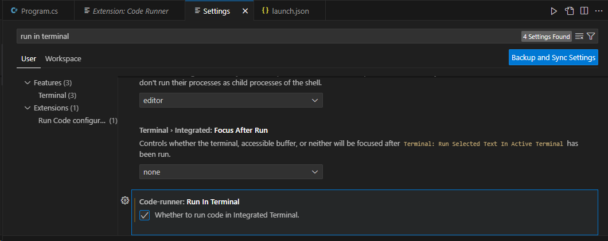

Click Open Setting(JSON) Button as indicated on below

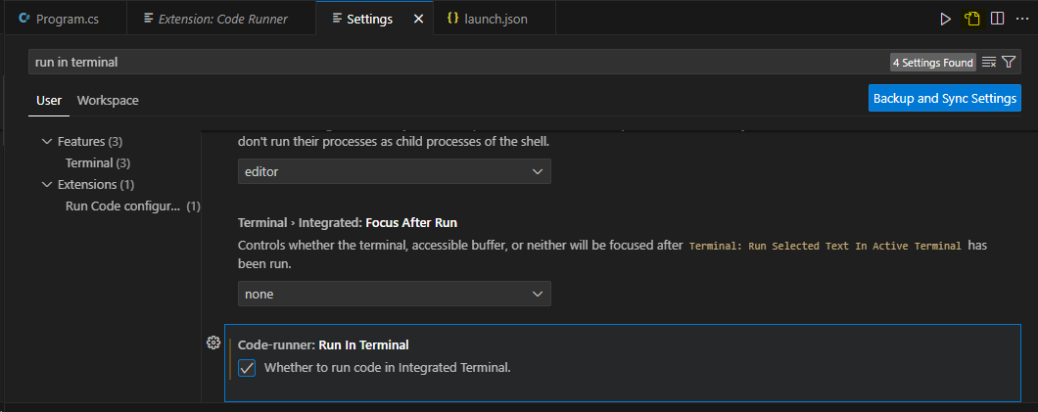

Click **Run** button as I indicated on below.

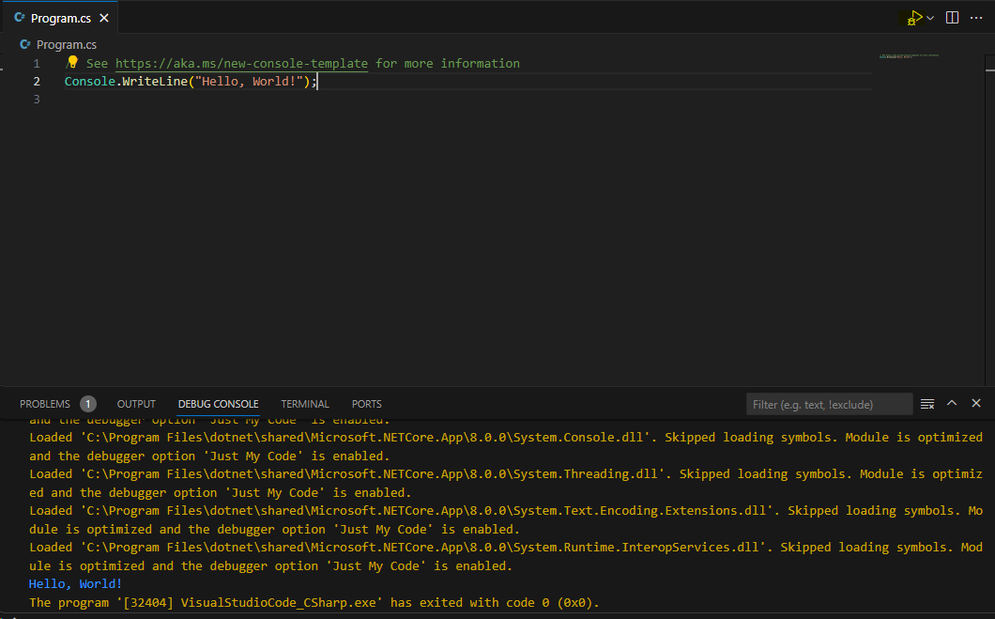

Important

dotnet new console –n “First program”

dotnet new ->create new project

dotnet build ->compile the app

dotnet run ->execute the app

Install the Selenium Webdriver for Selenium automation

Link: <https://www.selenium.dev/downloads/>

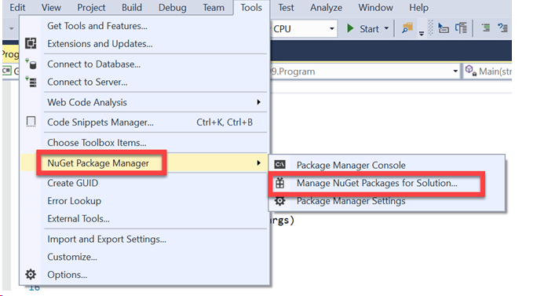

Refer below Link: <https://www.guru99.com/selenium-csharp-tutorial.html>

Goto Nuget-Solution and Type “Selenium”

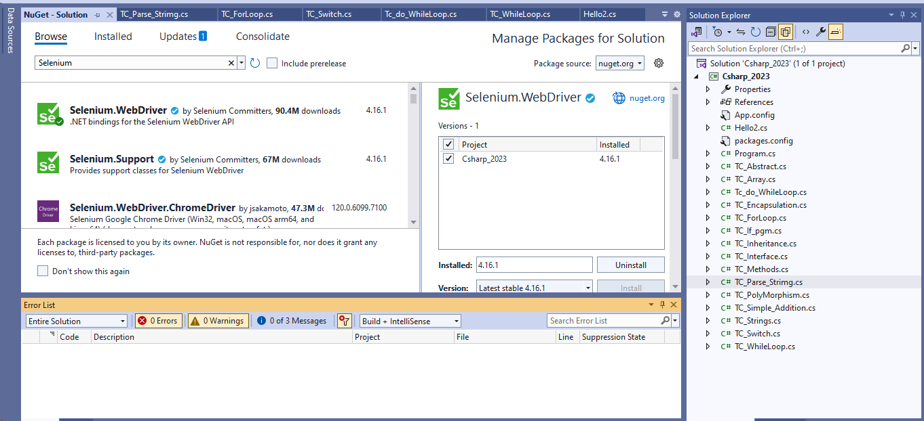

Install the ChromeDriver

Install Nuit framework

**Sample browser Execution results:**

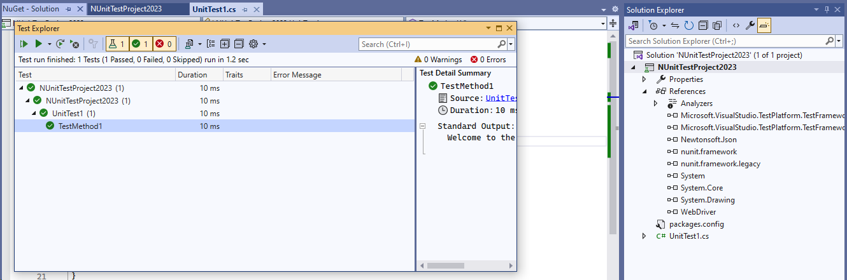

Login Test Execution result:

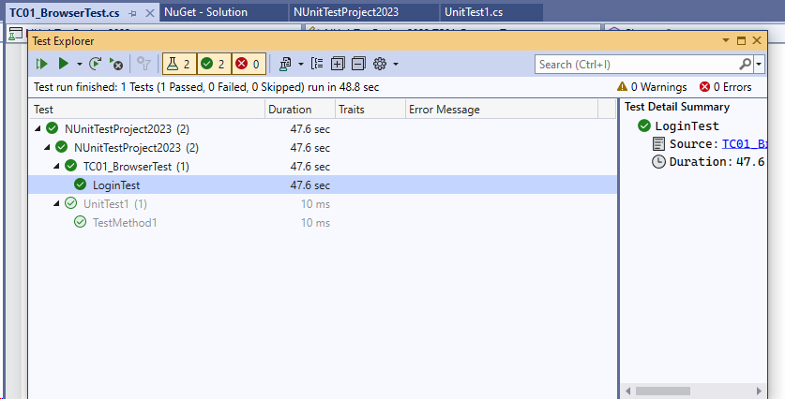

Login Test Code:Selenium With C#

using OpenQA.Selenium.Chrome;

using OpenQA.Selenium;

using System;

using System.Collections.Generic;

using System.Linq;

using System.Text;

using System.Threading.Tasks;

using System.Threading;

using NUnit.Framework;

using Microsoft.VisualStudio.TestTools.UnitTesting;

namespace NUnitTestProject2023

{

[TestClass]

internal class TC01_BrowserTest

{

//create the reference for the browser

IWebDriver driver;

[SetUp]

public void InvokeBrowser()

{

driver = new ChromeDriver();

//navigate to URL

driver.Navigate().GoToUrl("https://wecare.inspirisys.com/");

Thread.Sleep(2000);

}

[Test]

public void LoginTest()

{

IWebElement userField = driver.FindElement(By.Name("Username"));

userField.Click();

userField.SendKeys("100884");

IWebElement passwordField = driver.FindElement(By.Name("Password"));

passwordField.Click();

passwordField.SendKeys("ASHOK@123");

IWebElement submitBtn = driver.FindElement(By.XPath("//button[text()=\"Sign in\"]"));

submitBtn.Click();

Thread.Sleep(4000);

IWebElement imgTop = driver.FindElement(By.XPath("//li[@class=\"imgtop yellow1\"]"));

imgTop.Click();

IWebElement logoutBtn = driver.FindElement(By.XPath("//button[@class='log-location']"));

logoutBtn.Click();

}

[TearDown]

public void Cleanup()

{

//close the browser

driver.Close();

}

}

}

Note:For Dropdown selection Install Selenium.Support from Nuget

